Figure S1. Culvert at Beaver Creek before restoration. Culvert structure at Beaver Creek was believed to be in place since the early 1900s. Photo courtesy of Steve Brown.
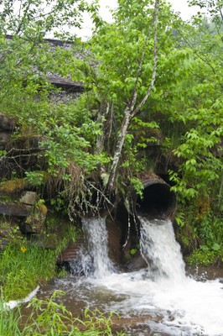
Figure S2. Culvert at Beaver Creek after restoration. Culvert replaced in June 2011. Photo courtesy of Paul Kinder.
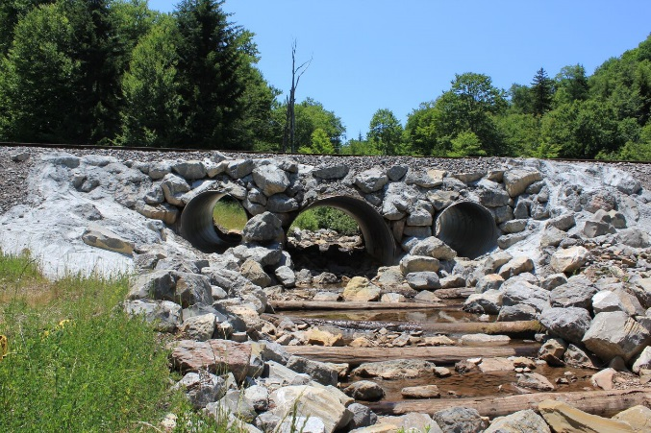

Figure S3. Culvert at Lamothe Hollow before restoration. Culvert structure at Lamothe Hollow was believed to be in place since the early 1900s. Photo courtesy of Paul Kinder.
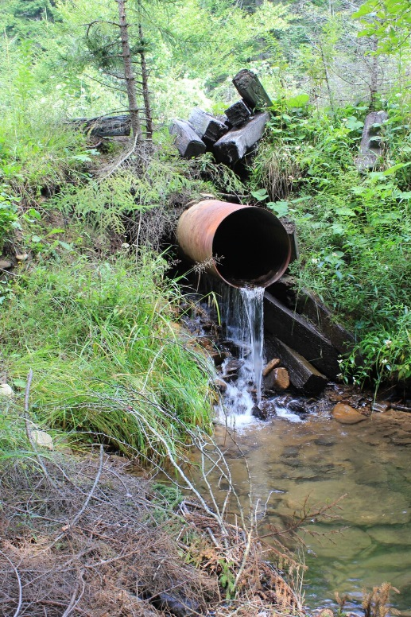
Figure S4. Culvert at Lamothe Hollow after restoration. Culvert structure replaced in June 2013. Photo courtesy of Paul Kinder.

